2025 Abstract Submission Guide

Use this guide as a workbook, entering your information on this form first before submitting your information on the ANPD website. Do not email completed guides to ANPD; abstracts must be submitted on the ANPD website. Please email speakers@anpd.org with any questions.

The abstract submission website can be accessed here. Click on the ANPD logo, and use your ANPD login to sign in to the site.

Primary Presenter and Speaker Details (Section 2)
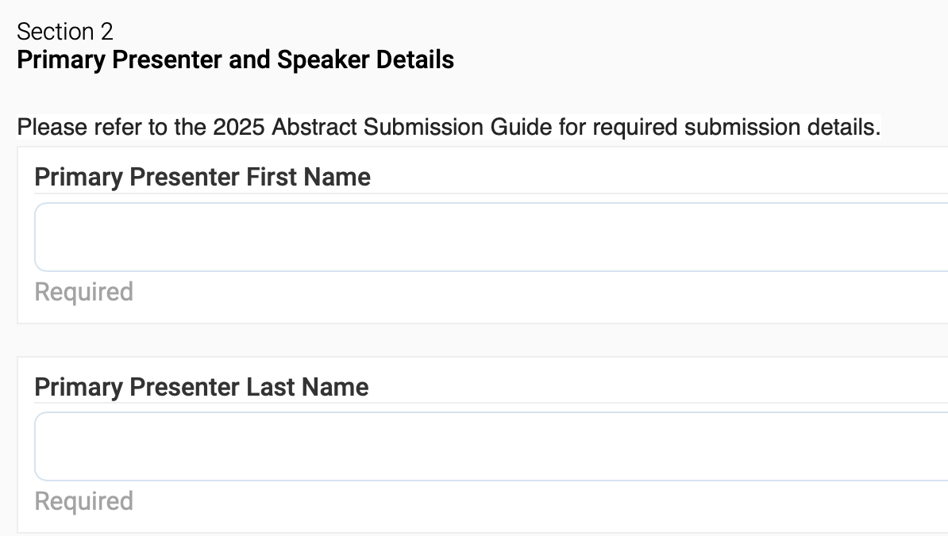
- As the primary presenter, enter your name, credentials, and a brief (35 word maximum) biography that describes you professionally, your email, and your employer.

Please Note: Concurrent sessions and posters submissions are limited to a total of no more than 4 presenters, including the primary presenter. Microlearning sessions are limited to no more than 2 presenters, including the primary presenter. Accepted presenters are encouraged to acknowledge all who contributed and are not presenting during their presentation.

Co-Presenters – If you have co-presenters, they can be added next by selecting yes to the question, “Would you like to add additional presenters?”
- You will then enter co-presenter information. As you type the co-presenter name, it will appear in the drop-down menu. This information is tied to the individual’s ANPD account. Their employer will display in parentheses if the person has entered this information in their ANPD account. Select the individual from the drop-down listing.

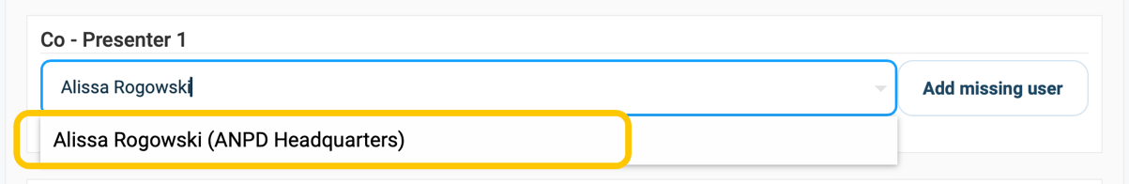

- If the co-presenter does not have an ANPD account, you may add them manually using “Add missing user.” In the next pop-up window, you will submit their name (include credentials), email, and enter in the comments section their employer, and a brief biography.
- Do not add a presenter under “Add missing user” unless you are certain that your co-presenter does not have an ANPD account. Please reach out to speakers@anpd.org if you are experiencing issues.

Tip: Identifying information, such as your name or your employer/organization’s name, should only be provided where specifically asked for in this section. Any identifying information found elsewhere, such as the abstract body, the respectful & equitable practice section, etc., will disqualify the abstract submission.

About Presentation (Section 3)

Title of Presentation:
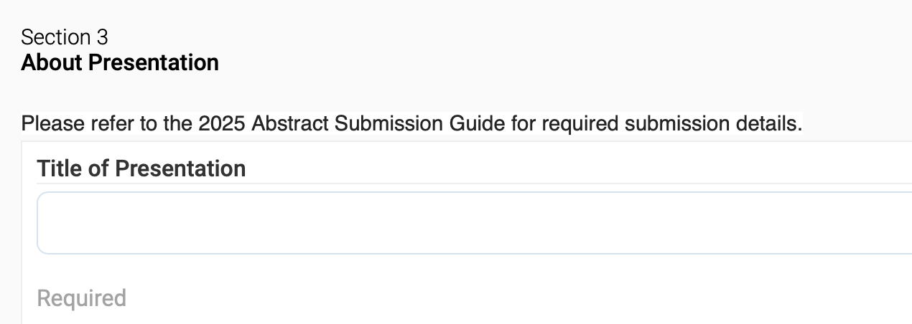
- Please enter your abstract title here; this is the name of your presentation.
- Use keywords from the abstract body.
- Provide a clear understanding of the abstract content within the title.
- The abstract title must be ten words or less.
- All words in the abstract title count toward title length. Symbols such as “&” and hyphenated words (e.g., in-person) count as one word.

Which type of presentation are you submitting an abstract for?

Select your preferred session type:
☐ Concurrent session (formerly Pathways) – the bulk of the convention oral presentations, these 30-minute or 60-minute sessions consist of an interactive verbal presentation and audience Q&A. You will be asked for your time preference (30 minutes or 60 minutes); ANPD reserves the right to determine the session length for concurrent sessions.
☐ Microlearning session (formerly Rapid Fires) – these fast paced, 15-minute oral presentations incorporate principles of microlearning to convey the highlights of the presenter’s work, with 10 minutes of presenting followed by 5 minutes of Q&A.
☐ Poster – Poster presentations are visual representations used to disseminate research, evidence-based practice, and new, innovative, and practical approaches that can be used in a variety of NPD settings.

Educational Track

Select the appropriate Educational Track that best matches your submission:

☐ Onboarding & Education – Sessions describe innovative onboarding/orientation processes. Onboarding is the fluid process of hiring, orienting, socializing, and integrating an employee to the organization with a focus on retention and growth. Orientation is one component of the onboarding process and is comprised of an individualized program to guide the new hire towards job competency. Focus for content may be on developing, coordinating, managing, facilitating, conducting or evaluating onboarding and orientation programs.
☐ Competency Management – Sessions describe innovative/transformational competency management processes. Competency management is a dynamic process designed to support ongoing assessment and evaluation of performance. Focus for content may be on the NPD expertise in competency assessment, development, coordination, management, facilitation, and evaluation of competency programs.
☐ Education – Sessions describe strategies used to improve professional practice (nursing and interprofessional education) and the provision of quality patient care. Content may relate to identification of practice gaps, initiatives developed to achieve outcomes in practice, and any component of the educational design process that enhances professional development as outlined in the Nursing Professional Development: Scope & Standards of Practice, 4th edition.
☐ Role Development – Sessions describe identification and application of strategies to facilitate continuous growth through ongoing professional learning as learners advance from novice to expert in their professions and specialties. This type of development allows for role transition, role integration, skill acquisition, and mastery. Content may relate to professional role development, practice role transitions, and succession planning.
☐ Collaborative Partnerships – Sessions describe mutually beneficial relationships between two or more individuals, groups, or organizations that work jointly toward common goals. These relationships may take place both within and external to the organization. Content may relate to partnerships to teach, coordinate, liaison, and/or advise concerning education and learning.
☐ Inquiry – Sessions describe participation in inquiry, which includes research, evidence-based practice (EBP), and quality improvement (QI) activities. Content may relate to promotion and integration of discovery, teaching, practice for the nursing professional development specialty and in patient care settings. Focus of content may be on conducting, evaluating, encouraging, consuming, facilitating, or participating in inquiry.

Sub-Category

Select the appropriate sub-category, if applicable:

☐ Leadership – Sessions describe how the NPD practitioner influences the interprofessional practice and learning environments, the NPD specialty, the profession of nursing, and healthcare. Content may also reflect demonstration of NPD value, return on investment, and leadership through collaborative partnerships with stakeholders.
☐ Diversity & Inclusion – Sessions describe professional development activities executed through a diversity and inclusion lens. Content may encompass any aspect of the human identity and/or experience, exemplifying how the NPD practitioner practices with cultural humility and inclusiveness. Content may also be related to social equity and determinants of health as well as global health awareness.
☐ Healthy Work Environment – Sessions describe activities for promoting a healthy work environment. Content may address the facilitation of positive practice and learning environments that promote staff safety, engagement, and retention. Content may also include strategies known to improve work environments, such as workplace violence prevention efforts and nurse well-being initiatives.
☐ Technology – Sessions describe activities that integrate the use of technology and its impact on educational strategies, learner engagement, and learning outcomes. Content includes the description of utilized technology without product or company promotion.
ANPD reserves the right to reassign educational track & sub-category to align with submitted content.

Session Description
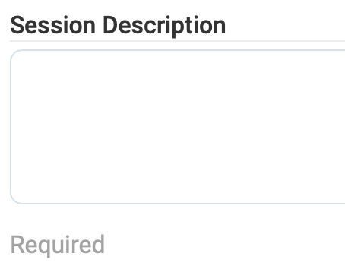
- Provide a short, compelling description of your planned presentation.
- Describes what participants should expect by attending your session.
- This description is used in promotional materials such as convention brochures and in the convention schedule descriptions, if accepted.
- Limit your abstract description length to 1 – 2 sentences
(maximum of 50 words).

Level of Intended Audience

The level of intended audience is for the participants attending your session, if accepted. In your abstract submission, you will be prompted to select which level of NPD practitioner would benefit most from this presentation based on the descriptions below. If expert level is indicated, you must list the Scope & Standards of Practice NPD specialist competencies addressed by your presentation to support your selection. ANPD reserves the right to recategorize presentations as appropriate.
☐ Novice
  - New to NPD
  - Practicing in NPD for 2 years or less
☐ Competent
  - Certified or working towards certification
  - Analyzes educational needs of individuals, organizations, or communities
  - Identifies desired NPD outcomes
  - Establishes and implements plans to achieve NPD outcomes
  - Evaluates progress toward attainment of outcomes
☐ Expert
  - Provides mentorship to novice and competent NPD practitioners
  - Role models for the specialty
  - Advanced skill or knowledge in leading NPD practice
  - Develops tools, theories, skills, and knowledge to advance the practice of the NPD specialty
  - Considered an expert by others
  - Integrates all roles of the NPD practitioner into practice

Expert Audience – list the NPD specialist competencies addressed in presentation. Use NPD specialist competencies from the defined standards in Nursing Professional Development: Scope & Standards of Practice, 4th Ed.

Abstract Body
Based on the NPD Practice Model, the abstract body is submitted within the context of the three components of the Nursing Professional Development Practice Model: Inputs, Throughputs, and Outputs. Refer to the Nursing Professional Development Scope & Standards of Practice, 4th Edition, for an in-depth explanation of the NPD Practice Model and the NPD practitioner role, standards, and competencies. Expert level abstracts and presentations should also address the additional competencies for the nursing professional development specialist.
Abstract body requirements are as follows:
- The abstract body is limited to a maximum of 500 words.
- Contains no personal or organizational identifiers, e.g., organization name, vendor name. Abstracts containing identifiers are disqualified and are not eligible for selection.
- The abstract addresses essential components of the presentation. Reviewers should be able to evaluate the content of the presentation from this portion of your submission.
- The abstract is concise and cohesive.
- The abstract should not contain citations; these will be listed in another section.

Abstract Body: Inputs, Throughputs, Outputs
The NPD inputs, throughputs, and outputs should be reflected in the abstract body. These elements reflect the educational design process and standards within the Nursing Professional Development: Scope & Standards of Practice, 4th Edition.

Inputs – Answers the “when, who, and how” of the NPD work being described.

Submitters are encouraged to consider including the following:
- Environmental Scanning and Assessment – Include evidence of thorough collection of pertinent data/information relative to individual, unit, organization, and/or system performance. In other words, what information was collected that contributed to the development of the NPD work being described?
- Demonstrate analysis of the gathered data and its implications on the practice gap, problem, or need.
- Demonstrate consideration of pertinent recognized benchmarks, organizational goals, or forecast needs based on environmental scanning with consideration of national and/or global forecasting as pertinent
- Demonstrate engagement of key interested/affected parties in the assessment process
- Directly link the measurable desired state identified to the problem/gap with data
- Identify and integrate evidence-based practices to support expected outcomes
- Align expected outcomes to organizational/system mission/strategic goals

Throughputs – Answers the “what” of the NPD scope of practice and work.

Submitters are encouraged to consider including the following:
- Clearly describe the involvement of collaborative relationships with key interested/affected parties in planning
- Clearly identify how the planned NPD work is expected to impact the outcome and addresses practice gap(s)
- Demonstrate individualization of NPD plan based on specific needs of learners, stakeholders, and/or organization
- Reflect innovative approaches to NPD initiatives
- Demonstrate evidence of systems thinking in planning process
- Strongly demonstrate utilization of evidence-based practice & adult learning principles in work
- Demonstrate principles of caring, respect, equity and inclusion in NPD initiatives implemented
- Demonstrate appropriate management or proactive resolution of implementation barriers
- Demonstration of NPD practice judgment in implementation

Outputs – The product of the NPD work being described, as it relates to the “why.”

Submitters are encouraged to consider including the following:
- Show a strong synthesis of evaluation development/methods with well-developed evaluation of learning, behavior changes and/or organizational outcomes identified
- Articulate monitoring of outcomes to guide monitoring/revising of current NPD activities and determine relevant future NPD initiatives
- Articulate sustainability plan with incorporation of opportunities to overcome barriers to sustain expected outcomes
- Articulate a well-developed return on investment (ROI) description of NPD initiatives demonstrating the impact of initiative with incorporation of sustainability

Write Your Abstract Body Here (500 word maximum)

Learner Engagement

Here, learner engagement refers to the active engagement of the Aspire Convention attendees, not the learners in your presented NPD work. Learner engagement is crucial to the success of your presentation, if selected. Learner engagement strategies must be congruent with your presentation format and the underlying educational needs you have identified. Presenters are encouraged to use effective, innovative, and exciting learner engagement methods.

Tip: Learner engagement methods are not teaching methods or teaching tools. Do not, for example, list “presentation slides” as a learner engagement method. Additionally, do not select methods that you used in your presented NPD work but do not plan to use during your convention presentation. For example, you should not select simulation because it was used in your presented NPD work, if you do not also intend to use simulation in your presentation at the Aspire Convention.

Select planned methods you will use at the Aspire convention to facilitate learner engagement. You may choose up to three methods that are pertinent to your presentation. All presentations will have a Q&A, so listing as such is not necessary in this section.
☐ Interactive dialogue
☐ Self-reflection
☐ Discussion groups
☐ Case study analysis
☐ Peer review
☐ Think-pair share
☐ Problem-based learning provision
☐ Simulation
☐ Other (please specify)

Literature References

This is the only section of your abstract submission where references should be listed. References listed in this section do not count toward the 500 word count limit.
- At least five references must be listed in complete APA 7th edition format (resource: Purdue OWL). You may omit hanging indents.
- References must be credible. Examples include evidence-based practice, peer reviewed journals and clinical guidelines.
- References must be current and published within the last five years. Exceptions include referencing a foundational/landmark work, such as: Benner, P. (1984). From novice to expert: Excellence and power in clinical nursing practice. Addison-Wesley
- Do not use in-text citations in the abstract body submission. Only list references in the reference section.

Learning Outcome

Enter in this field the expected learning outcomes for convention participants of your presentation. Learning outcomes are written in measurable terms, are tied to the identified professional practice gap, and convey what the learner should know, show, and/or be able to do after your presentation. Learning outcomes are not a list of learning objectives.

Your learning outcome may, for example, begin with, “By the end of this session, ANPD 2025 Aspire Convention learners will be able to know/show/do…”

Respectful & Equitable Practice

Guided by Standard 9 of the NPD Scope & Standards of Practice, “the NPD practitioner practices with cultural humility and inclusiveness” (Harper & Maloney, 2022, p. 91). Enter in this field how the NPD work you are submitting to present reflects, engages in, or supports cultural humility, social equity, inclusivity, allyship, and/or cultural practices and demonstrates diversity, equity, and inclusion in NPD practice. For example, you may enter how your presented work considers respectful communication, shared decision-making, addresses learner diversity, healthcare disparities or the social determinants of health. You may also enter how your presented work addresses digital access disparities, or engages in the recognition and elimination of microaggressions, biases, and social injustices. Do not submit organizational initiatives that are not part of the NPD work described in your submission. There is a maximum of 75 words for this response.

NPD Practice Environment
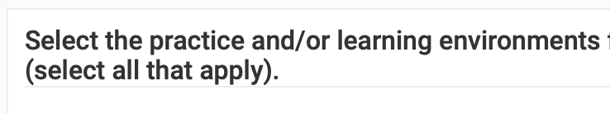

ANPD seeks abstracts with content that can be applied to multiple practice environments. All NPD activities occur in the context of the interprofessional practice and learning environments. Select the environments for which the concepts of your presentation can be applied. Please note that this asks where your concepts can potentially be applied, not just where you applied them in your presented work (check all that apply):

Interprofessional practice environment settings:  ☐ Acute care  ☐ Intermediate and/or long-term care  ☐ Ambulatory/Telehealth  ☐ Community/Home health  ☐ Multi-site organization  ☐ Multi-site, multi-state organization | Interprofessional learning environment:  ☐ Learners’ practice setting learning environment  ☐ Classroom  ☐ Virtual/online learning environment  ☐ Conference  ☐ Seminar/workshop setting  ☐ Independent, self-directed learning  ☐ Simulation environment  ☐ Academic partnership setting  ☐ Other:

Nature of Presentation

Here you will indicate whether your presentation is clinical in nature. If your presentation refers to patient care or products used in patient care, then select “Clinical” to this question. If your presentation does not address patient care or products used in patient care, then select “Non-Clinical.”

An example: If the session teaches how to manage Continuous Renal Replacement Therapy (a critical care patient treatment) and how to use the therapy equipment – yes, this session would be considered clinical in nature for two reasons: it teaches patient care, and it also discusses products used in patient care. If the session is focused on using an augmented reality teaching modality to facilitate clinician education during a Continuous Renal Replacement Therapy class – no, it is not considered clinical in nature.

☐ Clinical
☐ Non-Clinical

Knowledge & Subject Matter Expertise

Describe in this section your knowledge and subject matter expertise of your abstract submission content. Here is where you demonstrate your qualifications to present on this content. Do not include your name or your employer’s name.

Previous Presentation of Submitted Content

Indicate here whether the submitted content for the 2025 Aspire Convention has been presented through another national conference or publication. ANPD seeks innovative and original content submissions. Content of abstracts and presentations should be new and not shared through prior presentation at other venues. If the submitted content was presented previously, you will be asked to share details of prior presentations, and whether you are submitting additional information never presented.

Previous Presenter

Indicate here your experience presenting at any national conference. If you have previously presented at a national conference/convention on any topic, select “yes.”

Previous ANPD Presenter

Indicate here your experience presenting at any ANPD event. If you have previously presented at an ANPD event or activity on any topic, select yes. You will then be prompted to share the details of your past ANPD presentation.

Interest in Poster Presentation (Concurrent & Microlearning submissions only).

If you are submitting for a concurrent or microlearning session, you can opt for consideration for a poster presentation if your abstract is not selected for an oral session.

Please email speakers@anpd.org with any questions.

